- Tên và phân loại:

- Mục đích, ý nghĩa:
- Define a family of algorithms, encapsulate each one, and
make them interchangeable
- Lets the algorithm vary independently from clients that use it
- Động lực sử dụng:
- Many algorithms exist for breaking a stream of text into lines
- How can we configure an application to dynamically choose which
one to use?
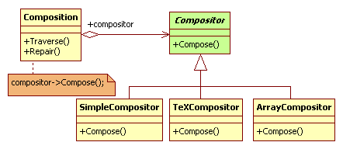
- Khi nào sử dụng:
- Many related classes differ only in their behavior
• Provide a way to configure a class with one of many behaviors
- You need different variants of an algorithm
• For example, you might define algorithms reflecting different
space/time trade-offs
• Strategies can be used when these variants are implemented as
a class hierarchy of algorithms
- An algorithm uses data that clients shouldn't know about
• Use the Strategy pattern to avoid exposing complex, algorithmspecific data structures
- A class defines many behaviors, and these appear as multiple
conditional statements in its operations
• Instead of many conditionals, move related conditional branches
into their own Strategy class
- Cấu trúc
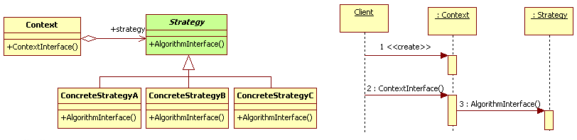
- Các thành viên - Sự cộng tác
- Strategy
• Declares an interface common to all supported algorithms
• Context uses this interface to call the algorithm defined by a
ConcreteStrategy
- ConcreteStrategy: implements the algorithm using the
Strategy interface
- Context
• Is configured with a ConcreteStrategy object
• Maintains a reference to a Strategy object
• May define an interface that lets Strategy access its data
- Các hệ quả mang lại:
- Families of related algorithms
• Hierarchies of Strategy classes define a family of algorithms or behaviors
for contexts to reuse. Inheritance can help factor out common functionality of the
algorithms
- An alternative to sub-classing
• Inheritance offers another way to support a variety of algorithms or behaviors. You
can subclass a Context class directly to give it different behaviors. But this hardwires
the behavior into Context. It mixes the algorithm implementation with Context's,
making Context harder to understand, maintain, and extend. And you can't vary the
algorithm dynamically. You wind up with many related classes whose only difference
is the algorithm or behavior they employ. Encapsulating the algorithm in separate
Strategy classes lets you vary the algorithm independently of its context, making it
easier to switch, understand, and extend
- Eliminate conditional statements
• Offers an alternative to conditional statements for selecting desired behavior. When
different behaviors are lumped into one class, it's hard to avoid using conditional
statements to select the right behavior. Encapsulating the behavior in separate
Strategy classes eliminates these conditional statements
- A choice of implementations
• Can provide different implementations of the same behavior. The client can choose
among strategies with different time and space trade-offs
- Chú ý liên quan đến cài đặt:

- Hệ thống thực tế

- Mẫu liên quan
▪ Flyweight: Strategy objects often make good flyweights

